1.GC First Run – Preparation run
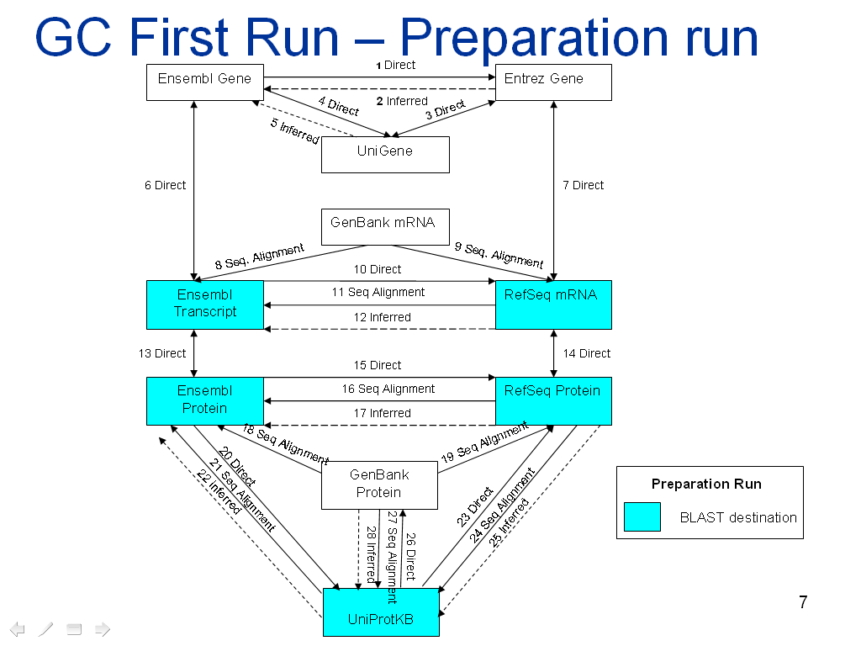

Parsers involved in Preparation run :
Destination:

1.Ensembl Transcript
2.Ensembl Protein
3.Refseq mRNA
4.Refseq Protein
5.UniProtKB

These parser’s will prepare the downloaded fasta files for blast in the First GC run (Preparation of BlastDB) .Thus, the fasta files will be formatted and form the blast destination database.

Blast source parsers:
1. GenbankmRNAParser
2. GenbankProteinParser
These parsers create organism wise single fasta files for blast.

2.GC Second Run- Annotation Parsers
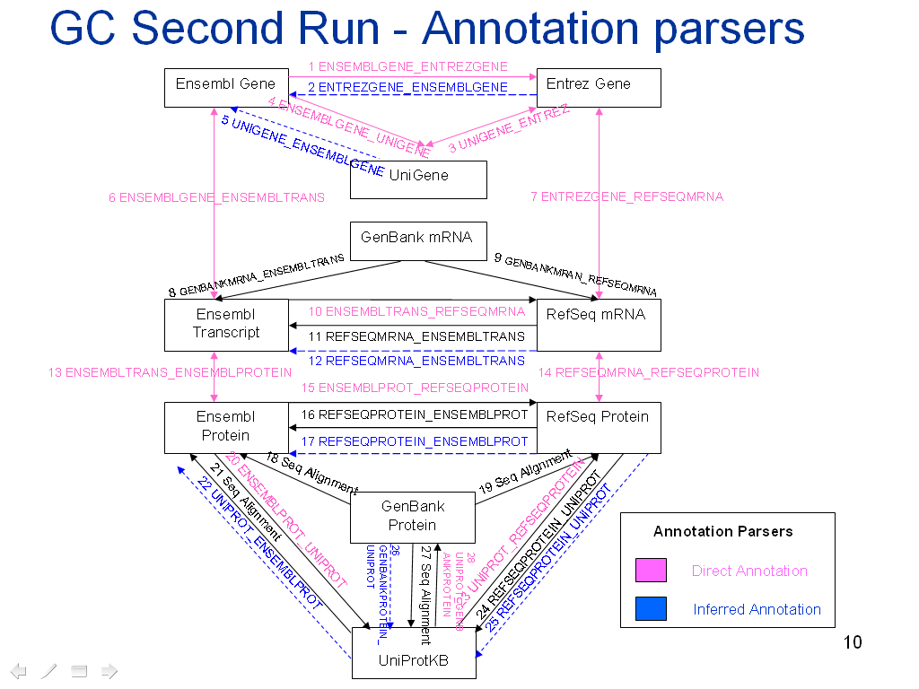

The Parser’s involved in the Second run are Annotation Parsers:
Annotation Parsers:
1.Unigene
2.Entrez_Unigene
3.Entrez_Refseq
4.Uniprot_GenBank
5.Uniprot_Refseq
6.Ensembl_Parser

The above mentioned Annotation parsers will populate the following links as numbered in the Graph for Second run: [Figure in the round brackets indicate Link number from graph]

Parser | Links Populated
Entrez_Unigene | UNIGENE_ENTREZ (3)
Entrez_Refseq | ENTREZGENE_REFSEQMRNA (7), REFSEQMRNA_REFSEQPROTEIN (14)
Uniprot_GenBank | UNIPROT_GENBANKPROTEIN (28), GENBANKPROT_UNIPROT (26)
Uniprot_Refseq | UNIPROT_REFSEQPROTEIN(23), REFSEQPROTEIN_UNIPROT(25)
Ensembl_Parser | ENSEMBLGENE_ENSEMBLTRANS (6)  ,ENSEMBLTRANS_ENSEMBLPROT(13),  ENSEMBLGENE_ENTREZGENE(1),  ENSEMBLGENE_UNIGENE(4),  ENSEMBLTRANS_REFSEQMRNA(10),  ENSEMBLPROT_REFSEQPROTEIN(15),  ENSEMBLPROT_UNIPROT(20),  ENTREZGENE_ENSEMBLGENE(2),  UNIGENE_ENSEMBLGENE(5),  REFSEQMRNA_ENSEMBLTRANS(12),  REFSEQPROTEIN_ENSEMBLPROT(17),  UNIPROT_ENSEMBLPROT(22).

3.GC Third run- Sequence Alignment Parsers
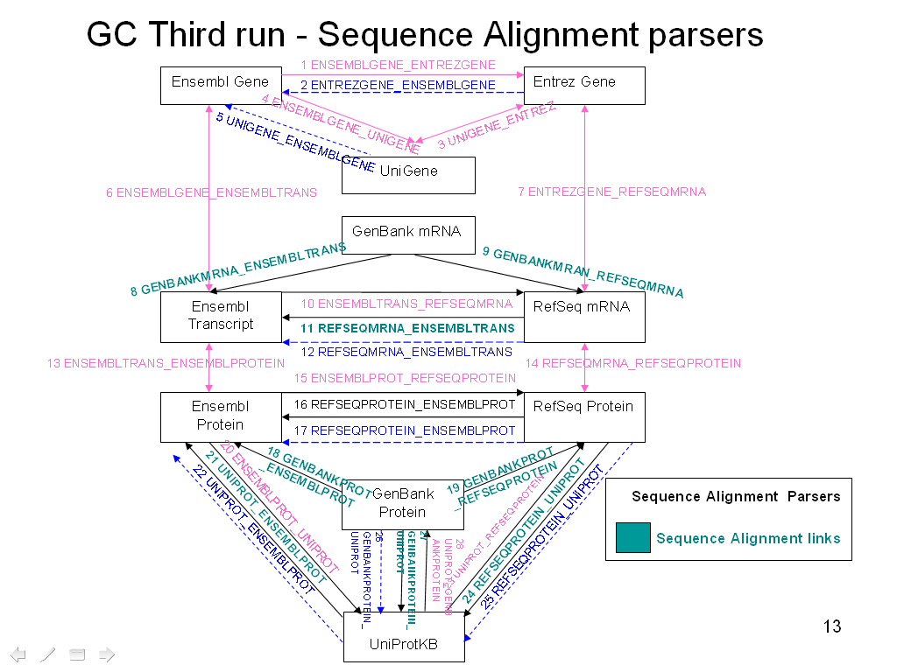

The Parser involved in the GC Third run is the Sequence Alignment Parser, i.e. the XMLRPC system. The XMLRPC system performs BLAST alignment and populates the Sequence Alignment Links for each pair as mentioned below:

[Figure in the round brackets indicate Link number from graph]

Sr. no. | Blast Pairs/Links populated
1. | GenBankmRNA with EnsemblTranscript (8)
2. | GenBankmRNA with RefSeqmRNA (9)
3. | GenBankProtein with EnsemblProtein (18)
4. | GenBankProtein with RefSeqProtein (19)
5. | GenBankProtein with Uniprot (25)
6. | RefSeqmRNA with EnsemblTranscript (11)
7. | RefSeqProtein with EnsemblProtein (16)
8. | RefSeqProtein with Uniprot (24)
9. | EnsemblProtein with Uniprot (21)

